Human Identity Concept Map

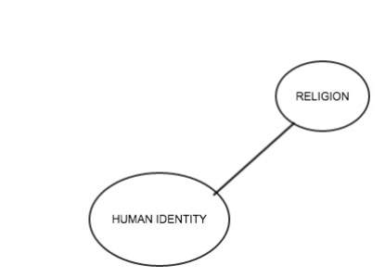

American Identity Concept Map

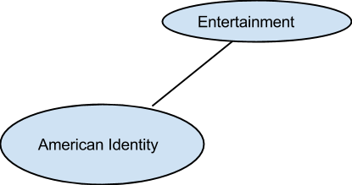

Who does John Steinbeck Say We Are?

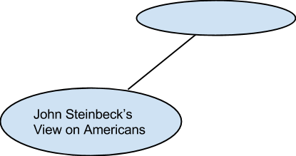

What does Media Say About American Identity?

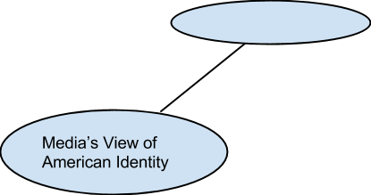

Other People’s Opinions of American Identity

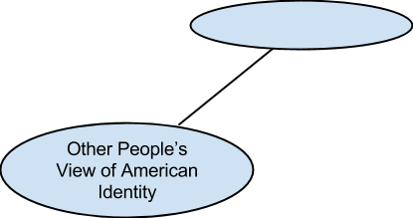

Directions: Draw your word cloud you created below.

Write Each of the words you used on the line and tell me WHY you picked those words.

1. ______________________ → I used this word because _______________________________________________________________
________________________________________________________________
2. ______________________ → I used this word because _______________________________________________________________
________________________________________________________________
3. ______________________ → I used this word because _______________________________________________________________
________________________________________________________________
4. ______________________ → I used this word because _______________________________________________________________
________________________________________________________________
5. ______________________ → I used this word because _______________________________________________________________
________________________________________________________________
6. ______________________ → I used this word because _______________________________________________________________
________________________________________________________________
7. ______________________ → I used this word because _______________________________________________________________
________________________________________________________________
8. ______________________ → I used this word because _______________________________________________________________
________________________________________________________________
9. ______________________ → I used this word because _______________________________________________________________
________________________________________________________________
10. ______________________ → I used this word because _______________________________________________________________
________________________________________________________________

Directions: Draw the Word Cloud you created in the space.

In a well constructed paragraph, with a topic sentence and concluding sentence, explain the words you chose, why you chose to make some of them bigger, and why they are the most important.

