Name:__________________________
Ms. Heyse
US History 2

Compare and Contrast Media and John Steinbeck’s view on American Identity.

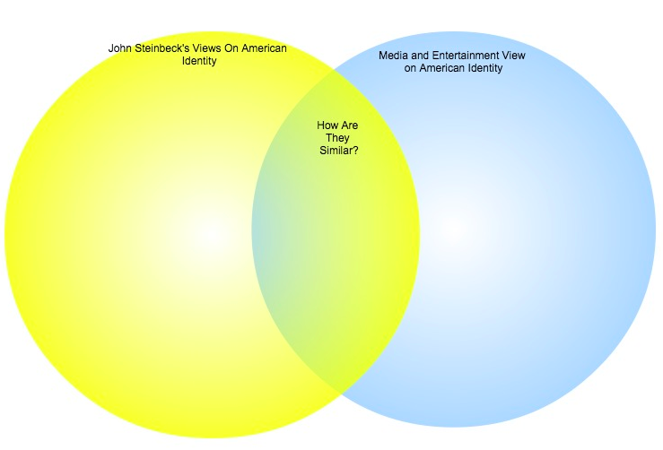
Name:__________________________
Ms. Heyse
US History 2

Compare and Contrast Media and John Steinbeck’s view on American Identity.
Whose views do you agree with the most, John Steinbeck or Media? Write at lease 3 sentences.

____________________________________________________________________________________________________________________________________________________________________________________________________________________________________________________________________________________________________________________________________________________________________________________________________________________________________________________________________________
Name:__________________________
Ms. Heyse
US History 2

In a well-constructed paragraph, make 3 comparisons between John Steinbeck and Media’s view on American Identity AND 3 differences between Steinbeck and media. Also, answer the question-- Whose view do you agree with most and why? Show me your best work.

____________________________________________________________________________________________________________________________________________________________________________________________________________________________________________________________________________________________________________________________________________________________________________________________________________________________________________________________________________
____________________________________________________________________________________________________________________________________________________________________________________________________________________________________________________________________________________________________________________________________________________________________________________________________________________________________________________________________________
____________________________________________________________________________________________________________________________________________________________________________________________________________________________________________________________________________________________________________________________________________________________________________________________________________________________________________________________________________
____________________________________________________________________________________________________________________________________________________________________________________________________________________________________________________________________________________________________________________________________________________________________________________________________________________________________________________________________________

