Name________________________________________________________Per___________________Date_________________

Look at the list of some of Charlemagne's achievements (successes).  Organize them into the following categories.  MILITARY (M) CULTURAL (C) RELIGIOUS (R)  Achievements Categories M/C/R  He enlarged his kingdom by defeating many different tribes.  He set up schools and encouraged the clergy to study holy texts and  ancient writers.  He developed an administrative system where the country was divided into  300 earldoms. Each was ruled by an earl who implemented his decisions  He spread Christianity to new areas. | 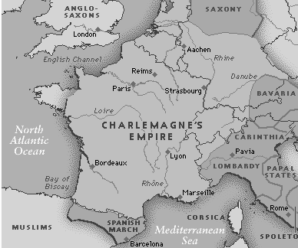
Describe the system of obligations that governed people in the Middle Ages.  Write complete sentences. | 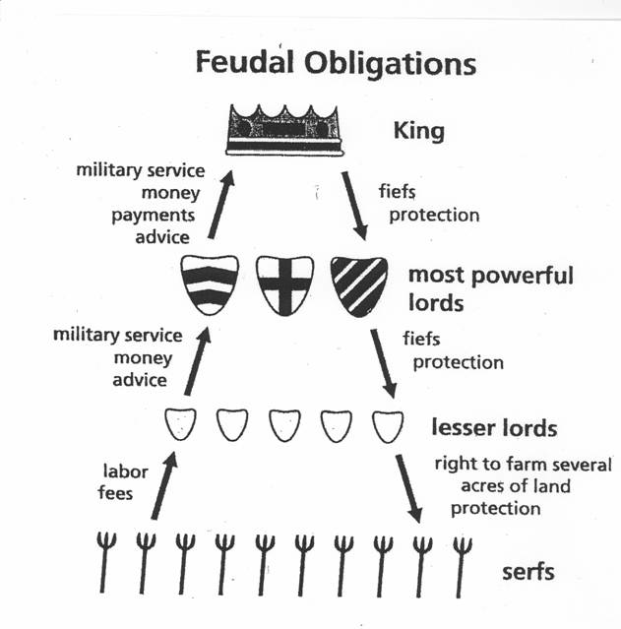
Describe what you see in the picture.  Write complete sentences. | 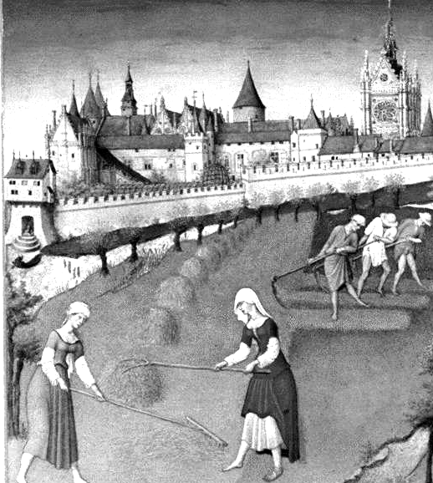

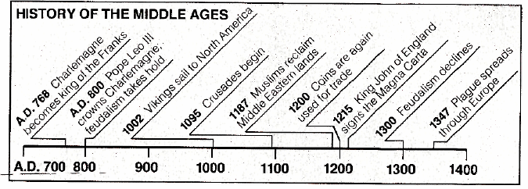
Write a summary of major events from A.D.700 to 1400. Write complete sentences.

